|  |
| --- |
| **D:\CE\WhatsApp Image 2021-05-08 at 4.35.03 PM.jpeg**  **“Cultivating excellence in every student”**    **RAKESH KUMAR**  **M.Sc. (Chemistry) B.Ed.**  **CTET, PSTET, HPTET qualified**  **chemistryexpert21@gmail.com** |
| **Class:-XII (Sci.) Name of Student……………………**  **Subject:- Chemistry**  **Chapter-2: SOLUTIONS** |

|  |
| --- |
|  |

**Expressing concentration of solutions**

**SOLUTIONS are homogeneous mixtures in which the substances are so thoroughly mixed that they cannot be distinguished from one another**.

Most solutions contain a solid **(solute)** dissolved in a liquid **(solvent)**; however, there are solutions of gases as well.

Composition of a solution can be described by expressing its concentration. The latter can be expressed either ***qualitatively or quantitatively***. For example, ***qualitatively we can say that the solution is dilute (i.e., relatively very small quantity of solute) or it is concentrated (i.e., relatively very large quantity of solute)***. ***But in real life these kinds of description can add to lot of confusion and thus the need for a quantitative description of the solution.***

There are several ways by which we can describe the concentration of the solution **quantitatively.**

The **CONCENTRATION** of a substance in solution provides away to find **how much of the substance exists in a given volume of the solution**.

**Chemists use the “mole” to describe the amount of substance in a solution**

A majority of reactions in the laboratories are carried out in solutions. Therefore, it is important to understand as how the amount of substance is expressed when it is present in the form of a solution. **The concentration of a solution or the amount of substance present in its given volume can be expressed in any of the following ways.**

**1. Mass per cent or weight per cent (w/w %)**

**2. Mole fraction**

**3. Molarity (M)**

**4. Molality (m)**

**5. Normality (N)**

**6. Parts per million (ppm)**

**1. Mass per cent or weight per cent (w/w %)**

Weight percent is often used to express the concentration of a solid substance dissolved in a liquid. The weight percent is equal to the weight of the substance (solute) divided by the total weight of the solution and multiplied by 100 to get a percentage.

Weight percent = $\frac{weight of solute }{total weight of solution}$ x 100

For example, a 1% sodium chloride solution in water contains 1 gram of sodium chloride (NaC*l*) in a total of 100 grams of solution. The amount of water is 99 grams, the difference between the total weight (100 grams) and the weight of the solute (1 gram).

**Volume Percent**

Volume percent is often used to express the concentration of a liquid solute in a liquid solvent. The volume percent is equal to the volume of the solvent divided by the total volume of the solution and multiplied by 100 to get a percentage.

**Volume percent = $\frac{Volume of solute }{total volume of solution}$ x 100**

Common rubbing alcohol is a 70% solution of rubbing alcohol (isopropyl alcohol) in water; that is, it contains 70 mL of isopropyl alcohol in 100 mL of total solution.

**2. Mole fraction**

The mole fraction is moles of target substance divided by total moles involved. The symbol for the mole fraction is the lower-case Greek letter chi, χ. It can be given with a subscript: χ solute is an example.

**Problem:** 0.100 mole of NaCl is dissolved into 100.0 grams of pure H2O. What is the mole fraction of NaCl?

Sol.

$\frac{100.0 g }{{18.0 g mol}^{-1}}$ = **5.56 mol of H2O**

Add that to the 0.100 mol of NaCl = 5.56 + 0.100 = 5.66 mol total

Mole fraction of NaCl = $\frac{0.100 mol }{5.66 mol }$ = 0.018

The mole fraction of the H2O = = 0.982

**Another way to figure out the last substance is 1.00 minus (the total of all other mole fractions). In this case 1.00 - 0.018 = 0.982.**

**Remember that all the mole fractions in the solution should total up to one.**

**Notice that the mole fraction has no units on it and is written as a decimal value. Do not change it to percent.**

**Problem:** A solution is prepared by mixing 25.0 g of water, H2O, and 25.0 g of ethanol, C2H5OH. Determine the mole fractions of each substance.

**Solution:**

1) Determine the moles of each substance:

H2O ⇒ = 1.34 mol 

C2H5OH ⇒ = 0.543 mol

2) Determine mole fractions:

H2O ⇒ = 0.71 

C2H5OH ⇒ = 0.29

**Problems for practice**

1. **A solution contains 10.0 g pentane, 10.0 g hexane and 10.0 g benzene. What is the mole fraction of hexane?**
2. **How many grams of water must be used to dissolve 100.0 grams of sucrose (C12H22O11) to prepare a 0.020 mole fraction of sucrose in the solution?**
3. **Surprisingly, water (in the form of ice) is slightly soluble in liquid nitrogen. At -196 °C, (the boiling point of liquid nitrogen) the mole fraction of water in a saturated solution is 1.00 x 10-5. Compute the mass of water that can dissolve in 1.00 kg of boiling liquid nitrogen.**
4. **What is the mole fraction of cinnamic acid in a mixture that is 50.0% weight urea in cinnamic acid (urea = 60.06 g/mol; cinnamic acid = 148.16 g/mol).**

**3. MOLAR CONCENTRATION or MOLARITY (M)** of a substance is the number of moles of the substance contained in **1 L of solution**.

i.e. Molarity = $\frac{No. ofmoles of solute}{Volume of solution in litres}$

Molarity of the solution = $\frac{W_{B }}{M_{B} ×V}$

If V is taken in ml (cm3), then

Molarity of the solution = $\frac{W_{B }}{M_{B} ×V}$ ×1000

**The unit of molarity is mol litre-1 or mol dm-3**

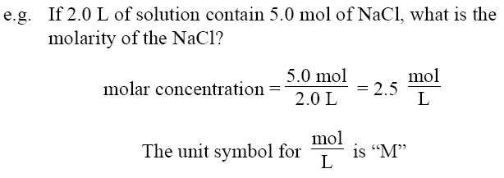

When expressed in words, the unit symbol **“M”** is written as **“molar”.**

The short-hand symbol for **“molar concentration of …”** is a set of brackets: **[…]**, so **[NaCl]** means the **“molar concentration of NaCl.”**

**If density’s’ of the solution in gm/ml and mass % (x %) of solute is given then the molarity can be calculated as**

As density‘d’ of solution = $\frac{mass of solution}{volume of solution}$

$∴$ Mass of 1 litre solution = (1000 × d) g

Or, mass of solute in 1 litre = $\frac{x}{100}$ × (1000 × d) g = (x × d × 10) g

Number of moles of solute in 1 litre = $\frac{Mass of solute in grams}{Gram molecular mass of solute}$ = $\frac{x ×d×10}{M_{B}}$

Where MB is gram molecular mass of solute

$∴$**M = $\frac{x ×d×10}{M_{B}}$**

**In case of dilution, the molarity can be calculated by using dilution formula which can be given as,**

**M1V1 = M2V2**

Where M1, M2, V1 and V2 are the molarities and volumes respectively.

**Molarity of mixture:**

When there are two or more samples of solution containing same solute and solvent with molarities M1, M2 ….and volumes V1, V2 …respectively.

**After mixing the molarity of mixed solution can be calculated as**,

**M1V1 + M2V2 +….. = MR (V1 + V2 + …..)**

**Or**

**MR =**

**Where, MR = resultant molarity or molarity of mixture.**

**Problems**

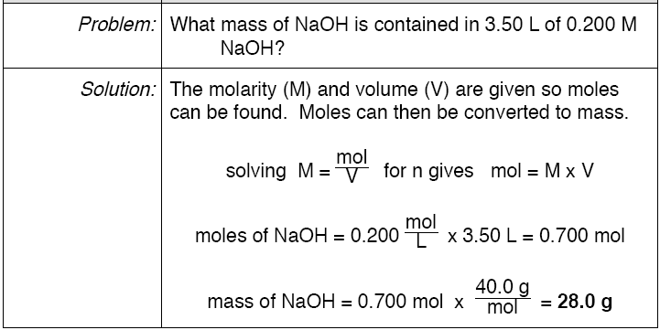

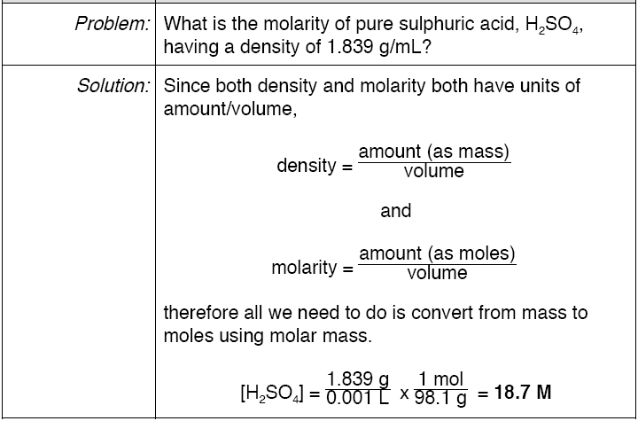

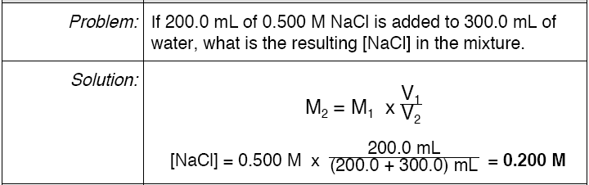

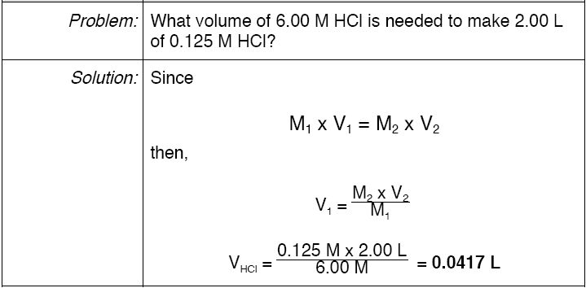

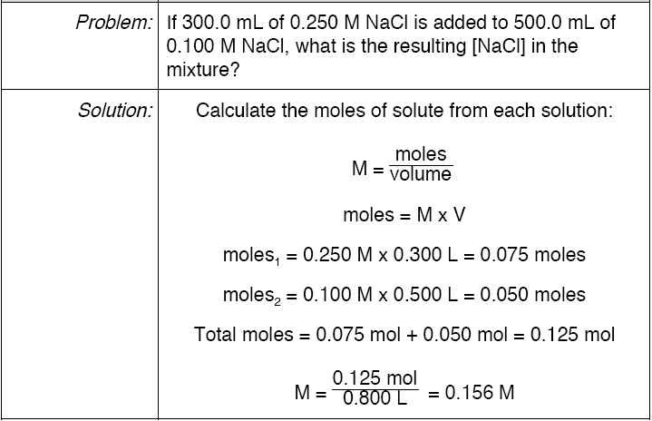

**4. Molality**

**It is defined as the number of moles of solute dissolved per kilogram of solvent. It is designated by the symbol ‘m’.**

The label 2.0 m H2SO4 is read “2 molal sulphuric acid” and is prepared by adding 2.0 mol of H2SO4 to 1 kg of solvent. Molality is expressed as:

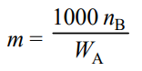

Where nB is the number of moles of the solute and WA is the mass in grams of solvent. The Molality of a solution does not change with temperature.

**Example 1: Find out the molarity of the solution which contains 32.0 g of methyl alcohol (CH3OH) in 200 mL solution.**

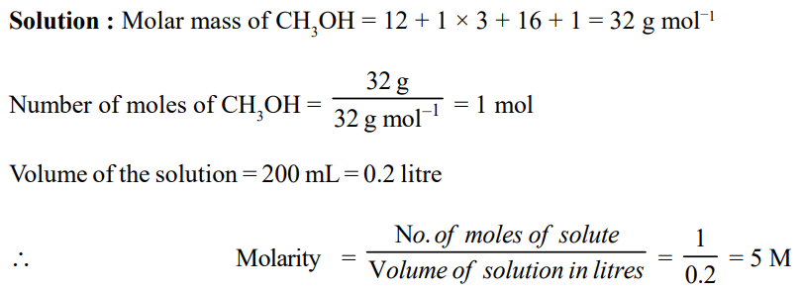

**Example 2: What is the Molality of a sulphuric acid solution of density 1.20 g/cm3 containing 50% sulphuric acid by mass?**

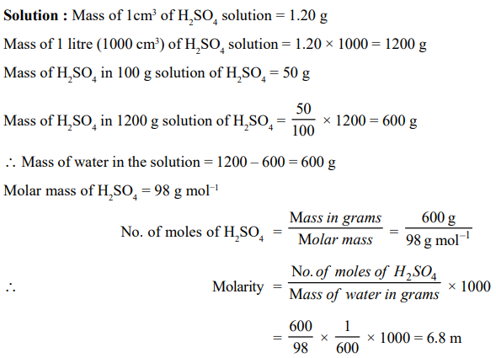

**5. Normality (N)**

**It is defined as the number of gram equivalents (equivalent weight in grams) of a solute present per liter of the solution.**

**Unit of normality is gram equivalents litre–1.**

**Normality changes with temperature since it involves volume.**

**When a solution is diluted ‘x’ times, its normality also decreases by ‘x’ times.**

Solutions in term of normality generally expressed as,

**N= Normal solution;  5N= Penta normal,**

**10N= Deca normal;  N/2 = semi normal**

**N/10 = Deci normal;  N/5 = Penti normal**

**N/100 or  0.01N= centinormal,**

**M/1000 or      0.001= millinormal**

**Mathematically normality can be calculated by following formulas,**

1. **Normality = $\frac{numberofofgm.equiv.ofsolute}{volumeofsolution (l)}$**
2. **N = $\frac{weight of solute in gms.}{gm.equiv.wt.of solute ×volume of solution (l)}$**
3. **N = $\frac{wt.of solute per liter of solution}{gm.eq.wt.of solute}$**
4. **N = $\frac{wt.of solute}{gm.eq.wt.of solute}$ × $\frac{1000}{volume of solution in ml}$**
5. **N = $\frac{percent of solute ×10}{gm.eq.wt.of solute}$**

1. **N = $\frac{strength in {gl}^{-1}of solution}{gm.eq.wt.of solute}$**

**(vii)  N = $\frac{wt \% ×density ×10}{eq.wt. }$**

1. **If volume V1 and normality N1 is so changed that new normality and volume N2 and V2 then,**

**N1V1 = N2V2 (Normality equation)**

**(ix) When two solutions of the same solute are mixed then normality of mixture (N) is**

**N = $\frac{N_{1}V_{1} + N_{2}V_{2}}{V_{1}+V_{2}}$**

**(x) Vol. of water to be added i.e., V2–V1 to get a solution of normality N2 from V1 ml of normality N1**

**V2–V1 = (**

**(xi)    Normality of the acidic mixture = $\frac{V_{1}N_{1}+ V_{2}N_{2}}{V_{1}+V_{2}}$**

**Solved Example**

**Ex.1 The molarity of 20% (W/W) solution of sulphuric acid is 2.55 M. The density of the solution is:**

**(A) 1.25 g cm-3 (B) 0.125 g L-1 (C) 2.55 g cm-3 (D) unpredictable**

**(Ans. A)**

**Sol.**Volume of 100 g of solution = https://edurev.in/edurev_content_assets/Class%2012/Chemistry/Theory/Liquid%20Solution/FiWMF132.JPG ml

M = https://edurev.in/edurev_content_assets/Class%2012/Chemistry/Theory/Liquid%20Solution/FiWMF133.JPG

Or d = https://edurev.in/edurev_content_assets/Class%2012/Chemistry/Theory/Liquid%20Solution/FiWMF134.JPG = 1.249 » 1.25

**Ex.2 The density of a solution containing 13% by mass of sulphuric acid is 1.09 g/mL. Calculate the molarity and normality of the solution-**

**(A) 1.445 M (B) 14.45 M (C) 144.5 M (D) 0.1445 M**

**(Ans. A)**

**Sol.**Volume of 100 gram of the solution = https://edurev.in/edurev_content_assets/Class%2012/Chemistry/Theory/Liquid%20Solution/FiWMF135.JPG

= https://edurev.in/edurev_content_assets/Class%2012/Chemistry/Theory/Liquid%20Solution/FiWMF136.JPG mL = https://edurev.in/edurev_content_assets/Class%2012/Chemistry/Theory/Liquid%20Solution/FiWMF137.JPG litre

= https://edurev.in/edurev_content_assets/Class%2012/Chemistry/Theory/Liquid%20Solution/FiWMF138.JPG litre

Number of moles of H2SO4 in 100 gram of the solution = https://edurev.in/edurev_content_assets/Class%2012/Chemistry/Theory/Liquid%20Solution/FiWMF139.JPG

Molarity = https://edurev.in/edurev_content_assets/Class%2012/Chemistry/Theory/Liquid%20Solution/FiWMF140.JPG

= https://edurev.in/edurev_content_assets/Class%2012/Chemistry/Theory/Liquid%20Solution/FiWMF141.JPG × https://edurev.in/edurev_content_assets/Class%2012/Chemistry/Theory/Liquid%20Solution/FiWMF142.JPG **= 1.445 M**

**Ex.3 Calculate the molarity of pure water (d = 1g/L)**

**(A) 555 M (B) 5.55 M (C) 55.5 M (D) None**

**(Ans. C)**

**Sol.** Consider 1000 mL of water

Mass of 1000 mL of water

= 1000 × 1 = 1000 gram

Number of moles of water = https://edurev.in/edurev_content_assets/Class%2012/Chemistry/Theory/Liquid%20Solution/FiWMF143.JPG = 55.5

Molarity = https://edurev.in/edurev_content_assets/Class%2012/Chemistry/Theory/Liquid%20Solution/FiWMF144.JPG

= https://edurev.in/edurev_content_assets/Class%2012/Chemistry/Theory/Liquid%20Solution/FiWMF145.JPG **= 55.5 M**

**Ex.4 Calculate the quantity of sodium carbonate (anhydrous) required to prepare 250 ml of**

**0.1 M solution-**

**(A) 2.65 gram (B) 4.95 gram (C) 6.25 gram (D) None**

**(Ans. A)**

**Sol.**We know that  
Molarity = https://edurev.in/edurev_content_assets/Class%2012/Chemistry/Theory/Liquid%20Solution/FiWMF146.JPG

Where;

W = Mass of Na2CO3 in gram

M = Molecular mass of Na2CO3 in grams =106

V =Volume of solution in litres = https://edurev.in/edurev_content_assets/Class%2012/Chemistry/Theory/Liquid%20Solution/FiWMF147.JPG = 0.25

Molarity = https://edurev.in/edurev_content_assets/Class%2012/Chemistry/Theory/Liquid%20Solution/FiWMF148.JPG

Hence, = https://edurev.in/edurev_content_assets/Class%2012/Chemistry/Theory/Liquid%20Solution/FiWMF149.JPG = https://edurev.in/edurev_content_assets/Class%2012/Chemistry/Theory/Liquid%20Solution/FiWMF150.JPG

Or W = https://edurev.in/edurev_content_assets/Class%2012/Chemistry/Theory/Liquid%20Solution/FiWMF151.JPG **= 2.65 gram**

**Ex.5** **Find the Molality of H2SO4 solution whose specific gravity is 1.98 g ml-1 and 95% by volume H2SO4**

**(A) 7.412 (B) 8.412 (C) 9.412 (D) 10.412**

**(Ans. C)**

**Sol.** H2SO4 is 95% by volume

wt. of H2SO4 = 95g

Vol of solution = 100ml

Moles of H2SO4 = , and weight of solution = 100 × 1.98 = 198 g

Weight of water = 198 _ 95 = 103 g

Molality = https://edurev.in/edurev_content_assets/Class%2012/Chemistry/Theory/Liquid%20Solution/FiWMF155.JPG = 9.412, Hence molality of H2SO4 solution is **9.412**

**Ex.6.** Calculate **molality of 1 litre solution of 93% H2SO4 by volume. The density of solution is 1.84 gm ml-1**

**(A) 9.42 (B) 10.42 (C) 11.42 (D) 12.42**

**(Ans. B)**

**Sol.**Given H2SO4 is 93% by volume

wt. of H2SO4 = 93g

Volume of solution = 100ml

weight of solution = 100 × 1.84 gm

= 184 gm

wt. of water = 184 _ 93 = 91 gm

Molality = https://edurev.in/edurev_content_assets/Class%2012/Chemistry/Theory/Liquid%20Solution/FiWMF156.JPG

= https://edurev.in/edurev_content_assets/Class%2012/Chemistry/Theory/Liquid%20Solution/FiWMF157.JPG = 10.42

**Ex.7** **Suppose 5gm of CH3COOH is dissolved in one litre of Ethanol. Assume no reaction between them. Calculate molality of resulting solution if density of Ethanol is 0.789 gm/ml.**

**(A) 0.0856 (B) 0.0956 (C) 0.1056 (D) 0.1156**

**(Ans. C)**

**Sol.**Wt .of CH3COOH dissolved = 5g, Eq. of CH3COOH dissolved = https://edurev.in/edurev_content_assets/Class%2012/Chemistry/Theory/Liquid%20Solution/FiWMF158.JPG

Volume of ethanol = 1 litre = 1000ml, Weight of ethanol = 1000 × 0.789 = 789g

Molality of solution = https://edurev.in/edurev_content_assets/Class%2012/Chemistry/Theory/Liquid%20Solution/FiWMF159.JPG = https://edurev.in/edurev_content_assets/Class%2012/Chemistry/Theory/Liquid%20Solution/FiWMF160.JPG = 0.1056

**Ex.8** **Calculate the molarity and normality of a solution containing 0.5 gm of NaOH dissolved in 500 ml. solution-**

**(A) 0.0025 M, 0.025 N (B) 0.025 M, 0.025 N**

**(C) 0.25 M, 0.25 N (D) 0.025 M, 0.0025 N**

**(Ans. B)**

**Sol.** Wt. of NaOH dissolved = 0.5 gm

Vol. of NaOH solution = 500 ml

**Calculation of molarity**

0.5 g of NaOH = https://edurev.in/edurev_content_assets/Class%2012/Chemistry/Theory/Liquid%20Solution/FiWMF161.JPG moles of NaOH

[Q Mol. wt of NaOH = 40]

= 0.0125 moles

Thus 500 ml of the solution contain NaOH = 0.0125 moles

1000 ml of the solution contain = https://edurev.in/edurev_content_assets/Class%2012/Chemistry/Theory/Liquid%20Solution/FiWMF162.JPG × 1000 = 0.025 M

Hence molarity of the solution =**0.025 M**

**Calculation of normality**

Since NaOH is mono acidic ;

Eq. wt. of NaOH = Mol. wt. of NaOH = 40

0.5 gm of NaOH = https://edurev.in/edurev_content_assets/Class%2012/Chemistry/Theory/Liquid%20Solution/FiWMF163.JPGgm equivalents = 0.0125 gm equivalents

Thus 500 ml of the solution contain NaOH = 0.0125 gmequ.

1000 ml of the solution contain

= https://edurev.in/edurev_content_assets/Class%2012/Chemistry/Theory/Liquid%20Solution/FiWMF164.JPG × 1000 = 0.025

Hence normality of the solution = **0.025 N**

**Ex.9** **Calculate the molality and mole fraction of the solute in aqueous solution containing 3.0 gm of urea per 250 gm of water (Mol. wt. of urea = 60).**

**(A) 0.2 m, 0.00357 (B) 0.4 m, 0.00357 (C) 0.5 m, 0.00357 (D) 0.7m, 0.00357**

**(Ans. A)**

**Sol.** Wt. of solute (urea) dissolved = 3.0 gm

Wt. of the solvent (water) = 250 gm

Mol. wt. of the solute = 60

3.0 gm of the solute = https://edurev.in/edurev_content_assets/Class%2012/Chemistry/Theory/Liquid%20Solution/FiWMF165.JPG moles = 0.05 moles

Thus 250 gm of the solvent contain = 0.05 moles of solute

1000 gm of the solvent contain = https://edurev.in/edurev_content_assets/Class%2012/Chemistry/Theory/Liquid%20Solution/FiWMF166.JPG = 0.2 moles

Hence molality of the solution = 0.2 m

**In short,**

Molality = No. of moles of solute/1000 g of solvent

Molality = https://edurev.in/edurev_content_assets/Class%2012/Chemistry/Theory/Liquid%20Solution/FiWMF167.JPG × 1000 = **0.2 m**

**Calculation of mole fraction**

3.0 gm of solute = 3/60 moles = 0.05 moles

250 gm of water = https://edurev.in/edurev_content_assets/Class%2012/Chemistry/Theory/Liquid%20Solution/FiWMF168.JPG moles = 13.94 moles

Mole fraction of the solute

= https://edurev.in/edurev_content_assets/Class%2012/Chemistry/Theory/Liquid%20Solution/FiWMF169.JPG = https://edurev.in/edurev_content_assets/Class%2012/Chemistry/Theory/Liquid%20Solution/FiWMF170.JPG = **0.00357**

**Ex.10** **A solution has 25% of water, 25% ethanol and 50% acetic acid by mass. Calculate the mole fraction of each component.**

**(A) 0.50, 0.3, 0.19 (B) 0.19, 0.3, 0.50 (C) 0.3, 0.19, 0.50 (D) 0.50, 0.19, 0.3**

**(Ans. D)**

**Sol.**

Since 18 g of water = 1 mole

25 g of water = https://edurev.in/edurev_content_assets/Class%2012/Chemistry/Theory/Liquid%20Solution/FiWMF171.JPG = 1.38 mole

Similarly, 46 g of ethanol = 1 mole

25 g of ethanol = https://edurev.in/edurev_content_assets/Class%2012/Chemistry/Theory/Liquid%20Solution/FiWMF172.JPG = 0.55 moles

Again, 60 g of acetic acid = 1 mole

50 g of acetic acid = https://edurev.in/edurev_content_assets/Class%2012/Chemistry/Theory/Liquid%20Solution/FiWMF173.JPG = 0.83 mole

Mole fraction of water = https://edurev.in/edurev_content_assets/Class%2012/Chemistry/Theory/Liquid%20Solution/FiWMF174.JPG = **0.50**

Similarly, Mole fraction of ethanol = https://edurev.in/edurev_content_assets/Class%2012/Chemistry/Theory/Liquid%20Solution/FiWMF175.JPG =**0.19**

Mole fraction of acetic acid = https://edurev.in/edurev_content_assets/Class%2012/Chemistry/Theory/Liquid%20Solution/FiWMF176.JPG = **0.3**

**Ex.11. 15 gram of methyl alcohol is dissolved in 35 gram of water. What is the mass percentage of methyl alcohol in solution?**

**(A) 30% (B) 50% (C) 70% (D) 75%**

**(Ans. A)**

**Sol.**Total mass of solution = (15 35) gram = 50 gram

mass percentage of methyl alcohol

= https://edurev.in/edurev_content_assets/Class%2012/Chemistry/Theory/Liquid%20Solution/FiWMF177.JPG × 100

= https://edurev.in/edurev_content_assets/Class%2012/Chemistry/Theory/Liquid%20Solution/FiWMF178.JPG × 100 = **30%**

**Ex.12 Calculate the masses of cane sugar and water required to prepare 250 gram of 25% cane sugar solution-**

**(A) 187.5 gram, 62.5 gram (B) 62.5 gram, 187.5 gram**

**(C) 162.5 gram, 87.5 gram (D) None of these**

**(Ans. B)**

**Sol.**Mass percentage of sugar = 25

We know that

Mass percentage = https://edurev.in/edurev_content_assets/Class%2012/Chemistry/Theory/Liquid%20Solution/FiWMF179.JPG × 100, So, 25 = https://edurev.in/edurev_content_assets/Class%2012/Chemistry/Theory/Liquid%20Solution/FiWMF180.JPG × 100

or Mass of cane sugar = https://edurev.in/edurev_content_assets/Class%2012/Chemistry/Theory/Liquid%20Solution/FiWMF181.JPG = **62.5 gram**

Mass of water = (250 - 62.5) = **187.5 gram**

**Ex.13** **Calculate normality of the mixture obtained by mixing 100ml of 0.1N HCl and 50ml of 0.25N NaOH solution.**

**(A) 0.0467 N (B) 0.0367 N (C) 0.0267 N (D) 0.0167 N**

**(Ans. D)**

**Sol.**Meq. ofHCl =100 × 0.1 = 10

Meq.ofNaOH = 50 × 0.25 = 12.5

Q HCl and NaOH neutralize each other with equal eq.

Meq.ofNaOH left = 12.5 _ 10 = 2.5

Volume of new solution = 100 50 = 150 ml.

NNaOHleft = https://edurev.in/edurev_content_assets/Class%2012/Chemistry/Theory/Liquid%20Solution/FiWMF182.JPG = 0.0167 N

Hence normality of the mixture obtained is **0.0167 N**

**Ex.14.** **300 ml 0.1 M HCl and 200 ml of 0.03M H2SO4 are mixed. Calculate the normality of the resulting mixture-**

**(A) 0.084 N (B) 0.84 N (C) 2.04 N (D) 2.84 N**

**(Ans.A)**

**Sol.** For HC*l*F or H2SO4

V1 = 300 ml V2 = 200 ml

N1 = M x Basicity N2 = M x Basicity

= 0.1 x 1 = 0.1 = 0.03 × 2 = 0.06

Normality of the mixture,  N = https://edurev.in/edurev_content_assets/Class%2012/Chemistry/Theory/Liquid%20Solution/FiWMF183.JPG = https://edurev.in/edurev_content_assets/Class%2012/Chemistry/Theory/Liquid%20Solution/FiWMF184.JPG = https://edurev.in/edurev_content_assets/Class%2012/Chemistry/Theory/Liquid%20Solution/FiWMF185.JPG =**0.084 N**

**Ex.15 Calculate the amount of each in the following solutions –**

1. **150 ml of**https://edurev.in/edurev_content_assets/Class%2012/Chemistry/Theory/Liquid%20Solution/FiWMF187.JPG**H2SO4 (ii) 250 ml of 0.2M NaHCO3**

**(iii) 400 ml of https://edurev.in/edurev_content_assets/Class%2012/Chemistry/Theory/Liquid%20Solution/FiWMF188.JPG Na2CO3 (iv) 1052 g of 1 m KOH.**

**(A) 52g, 2.12g, 4.2g, 1.05g (B) 1.05g, 4.2g, 2.12g, 52g**

**© 1.05g, 2.12g, 52g, 4.2g (D) 4.2g, 2.12g, 1.05g, 52g**

**(Ans. B)**

**Sol.**(i) Eq. wt. of H2SO4 = https://edurev.in/edurev_content_assets/Class%2012/Chemistry/Theory/Liquid%20Solution/FiWMF189.JPG= https://edurev.in/edurev_content_assets/Class%2012/Chemistry/Theory/Liquid%20Solution/FiWMF190.JPG = 49

Amount of H2SO4 per litre (strength) = Normality × Eq. wt. = × 49 = 7 g/litre

Amount in 150 ml = https://edurev.in/edurev_content_assets/Class%2012/Chemistry/Theory/Liquid%20Solution/FiWMF191.JPG = 1.05 g

(ii) Molecular wt. of

NaHCO3 = 23+ 1+ 12 +48 = 84

Amount of NaHCO3 required to produce 1000 c.c. of one molar solution = 84 g

Amount present per litre in 0.2 M solution = 84 × 0.2 = 16.8 g

Amount present in 250 c.c. = https://edurev.in/edurev_content_assets/Class%2012/Chemistry/Theory/Liquid%20Solution/FiWMF192.JPG = 4.2 g

Equivalent weight of Na2CO3 = https://edurev.in/edurev_content_assets/Class%2012/Chemistry/Theory/Liquid%20Solution/FiWMF193.JPG = 53

Amount of Na2CO3 = Normality × Eq. wt. = × 53 = 5.3 g/litre

Amount present in 400 c.c. = https://edurev.in/edurev_content_assets/Class%2012/Chemistry/Theory/Liquid%20Solution/FiWMF194.JPG = 2.12 g

We know that 1 molal solution of a substance contains 1000 g of solvent.

Wt. of KOH in 1052 g of 1 m KOH solution = 1052 _ 1000 = 52 g

**Ex.16** **How many kilograms of wet NaOH containing 12% water are required to prepare 60 litres of 0.50 N solution? (A)** **1.36 kg (B) 1.50 kg (C) 2.40 gm (D) 3.16 kg**

**(Ans. A)**

**Sol.**One litre of 0.50 N NaOH contains = 0.50 × 40g = 20 g = 0.020 kg

60 litres of 0.50 N NaOH contain

= 0.020 × 60 kg = 1.20 kg NaOH

Since the given NaOH contains 12% water, the amount of pure NaOH in 100 kg of the given NaOH = 100 - 12 = 88 kg

Thus 88 kg of pure NaOH is present in 100 kg wet NaOH

* 1. kg of pure NaOH is present in = https://edurev.in/edurev_content_assets/Class%2012/Chemistry/Theory/Liquid%20Solution/FiWMF195.JPG × 1.20 = **1.36 kg wet NaOH**

**,,……………**